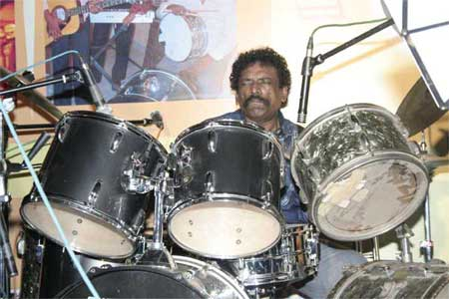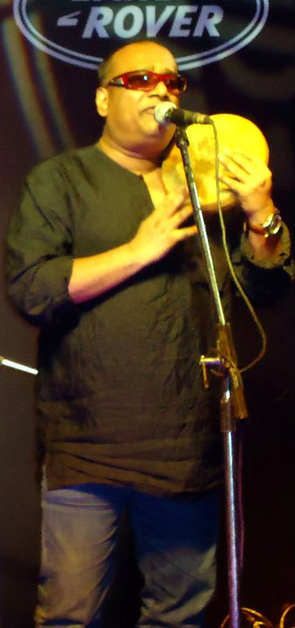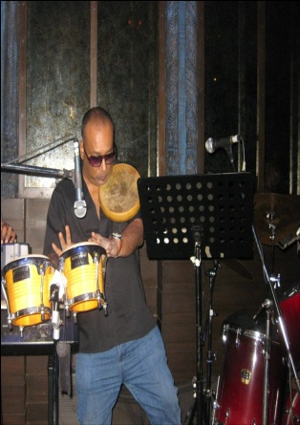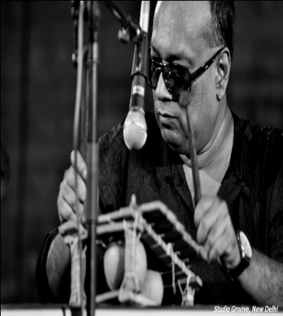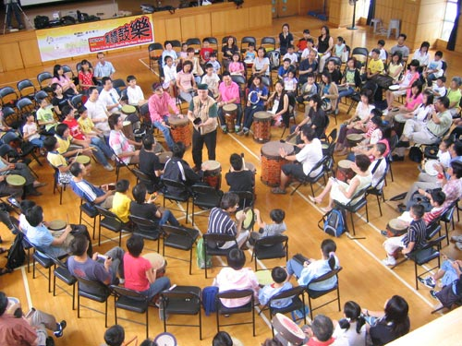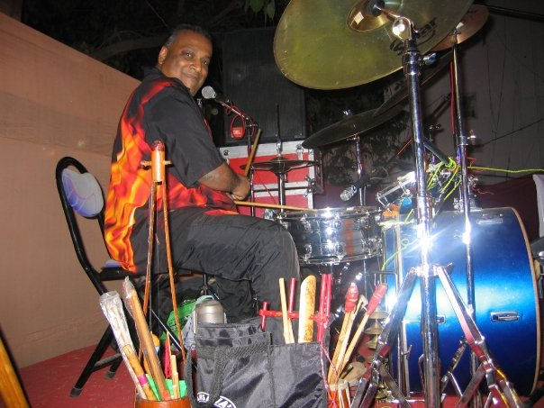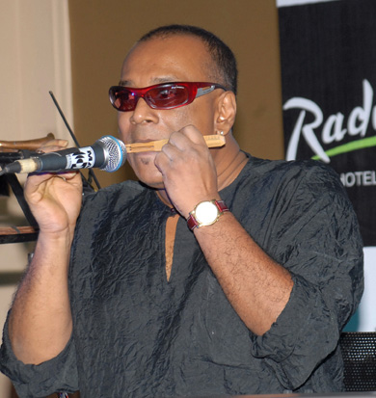
Drummers & Strummers Jammin – Not Just a Drum Jam
- DSJ is skillfulness!
- DSJ is character!
- DSJ is understanding diversity!
- DSJ is collaboration
- DSJ is learning!
- DSJ is life!
- DSJ is integrity!
- DSJ is self discovery!
- DSJ is values & ethics!
- DSJ is attitude… Positive Attitude to be & lead the change.
DSJ is an Intellectual Property owned by “icongo intel & associates” and “Karma Kurry Learning & Human Development”, the only India-based training company that incorporates the philosophy of interactive music, NLP, Gestalt and Motivational Speaking in the module. Founded by Gautam Ghosh globally renowned Percussionist and Musician par excellence, in association with motivational speakers, NLP / Gestalt practitioners like Reeti Sahai, Jyoti Nanda, Julie George, Meenu Chopra, Bosco Fernandes, Hunar Brar and Jerry Almeida. DSJ has created a module that not only creates a lot of fun for participants but also helps them get rid of their inhibitions and discovering their TRUE POTENTIAL by getting in touch with their inner self and knowing more about how to do things by using all their 5 senses. (Auditory, Visual, Kinesthetic, Olfactory and Gustatory). This session will help enhance the listening power, attentiveness and interpersonal communications of participants and make them team players. The DSJ session shall also help people connect with their inner self and others and be aware of the unconscious which would in turn help them to activate the left brain and discover their power to be creative , contribute with ideas and out of the box thinking on the feet.
DSJ programs are designed to rid you of your inhibitions, align with a common vision, discover and rejoice conflict and learn to accept each and everyone’s matchless contribution, while helping each one to CONNECT with EVERYONE’s self expression and leadership. DSJ has been successfully conducted for community events (youth fests in association with HT, the UN, British High Council for large 5000+ gatherings), corporate events for AGMs, Sales Meets and other annual meetings & trainings (we have organized this for Banks, Financial, Healthcare, Media & Telecom Companies) and for educational institutes (schools, colleges, law institutes & B-schools)
We connect the power of the drumming, strumming, gyrating, free spirit dancing, breathing and Shaman chanting blended with the ethos of NLP & Gestalt and deliver it to you through a range of inspirational leadership programs.
Our hands-on programs include corporate coaching & infotainment, team-building workshops, leadership skills training, drumming for trauma relief, as well as children’s parties and community drum sessions. We can perform in just about any location for groups small or large and for up to thousands of people.
We have percussionists and musicians who are world class and living legends which besides Gautam Ghosh, include the blind Maestro Babush Santana, India’s one in a billion country legend Bobby Cash and various other legendary musicians from India & overseas (based on your budget).
Whatever your needs, our qualified facilitators & speakers can create a CUSTOM TAILORED program suitable for you.
DSJ has the following programs and more to offer as customized solutions.
- Dalit Drums
- Feel The strums
- Chanting for peace of mind
- Body percussion
- Let’s go guitar
- Tongues
- Live performances
- Sing Along
- Motivational Talk with music and drum effect. (This will be a high energy, talk by Motivational Speaker Jerry Almeida)
- Dance and explore your hidden potential.
- Burmanisms.
- Let’s Rock n Roll
- Ojah ye Ojah (Trademark program- only the experience can tell you what it is)
Drummers & Strummers Jammin is the only one of its kind program that blends various training modules, Motivational speech and stories or uncommon unsung heroes and Auditory Perceptional Training APT for Team Building and Corporate Events. It is a unique yet relevant program used by many of the Fortune 500 companies worldwide. Drumming is something everyone and every culture can relate to. The first thing you hear when you come into this world is the beat of your mother's heartbeat. Drumming relaxes, energizes and motivates in a way most team building companies cannot explain. This is Interactive Drumming that helps for building teams and connecting people to work towards common goals Each individual is important to the group. Drummers & Strummers Jammin interactive drumming allows everyone to feel motivated and rewarded because their involvement contributes to the success. Groups can achieve so much more. Here drumming and other auditory perception training is used in a relaxed environment to break down barriers, inspire people and bring people together.
AUDITORY PERCEPTIONAL TRAINING or APT is designed to create greater self awareness in order to express oneself in a most demanding & most challenging working environment in a harmonious and creative way.
It invigorates one’s own core essentials and nurtures values of integrity by aligning these with their pre-existing skill sets thus empowering the individual to address professional and personal life propositions as an extension of the same fabric of life energies that is not a collage of perceived contradictions!
The programme enables participants to re-visit ones inner strengths and doubts in a positive sense of appreciation which enables them to realize their own inherent potential as simply unique and exclusive. This in turn brings in a fresh approach to a deeper understanding of natural laws that govern us all in whatever we strive to do.
APT simply strives to raise new levels of self assertion as a definitive tool to enhance team building ethos without compromising on self confidence and self esteem. It creates and recreates and furthers the cause of greater unity through using the benefits of diversity in proclaiming the vision statement of the esteemed organization as its very own mantra.
APT uses its own self-evolved “dynamic sonic language” in the implementation sessions.
For eg. --- simultaneous multiple percussions, dynamic natural audio generators, primal chants, body beats, gibberish, rhythmic body movements without navigation, free-form orchestration,
Individual n collective response mechanism, air musical enactments, soft tonal appreciation n meditation, high energy expressions, anti-stress sonic silencers, etc. etc.
APT has the inherent ability to manifest itself into a more specific need-based customized session implementation module. Its most singular purpose is to build a lasting bridge of internal and external connect that is both profitable and responsible without prejudice and contradictions.
APT opens up new perceptions , new horizons, new hopes, new understandings and new appreciations towards all things big and small .....it re-establishes the divine connect in the professional-personal-social-spiritual domain in a most entertaining and delightful way.
APT is most apt if one has plans to reach in and to reach out. Meaningfully.
APT has been evolved and designed by Gautam Ghosh in association with all the motivational speakers at Karma Kurry- Learning & Human Development.

